MET AD715 A4 Quantitative and Qualitative Decision-Making
Individual Assignment 2
By

Xueyang Long
3/18/2020
Table of Contents
Executive Summary 3
1. Payoff tables and decision tree. 4
2. EMVs for each alternative. 5
(1) EMV for not hiring a business analyst. 5
(2) EMV for hiring a business analyst. 6
(3) Final solution and recommendation. 6
3. Sensitivity analysis. 6
4. The decision tree with payoffs, probabilities, and EMVs. 8
References 9
Tables 10
Figures 12

Executive Summary
The real estate company is considering to develop one of the following building: an apartment building, an office building and a warehouse. The company also need to decide if they should hire a business analyst. By using Excel, we construct the decision tree and calculate the EMVs for each alternative, we find that developing an apartment building and not hiring an analyst is most favorable for the company.
Moreover, we also conduct sensitive analysis in Excel, a cross point appears, which shows when the probability of positive survey result is 0.98, the EMV for hiring an analyst equals the EMV for not hiring an analyst which is 341900.
Therefore, we strongly recommend the company to develop an apartment building, and there is no need to hire an business analyst.

1. Payoff tables and decision tree.
The company can choose either hire a business analyst or not hire a business analyst. If they choose not hire a business analyst, they don’t need to pay survey fee. If they decided to hire an analyst, they need to pay extra $7000 survey fee.
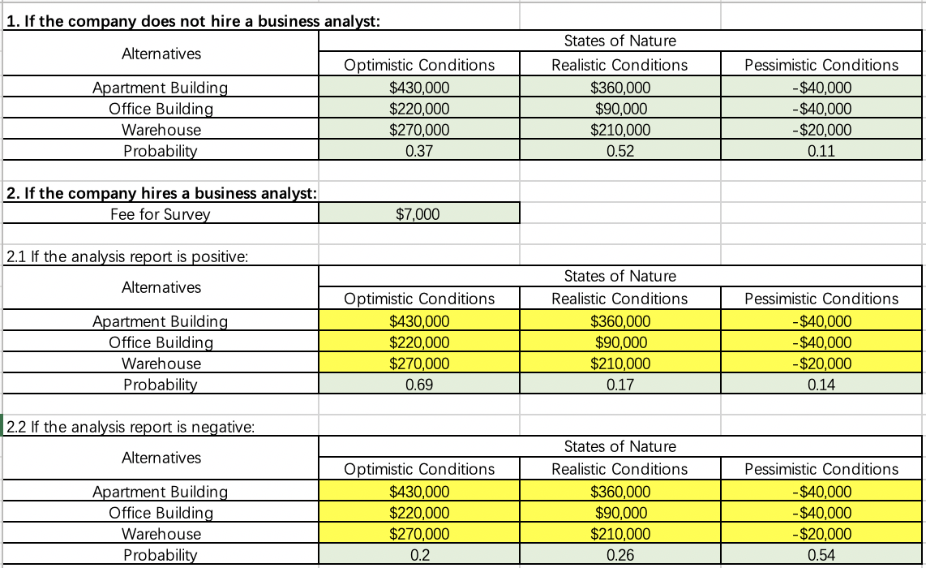
Table 1
The decision tree is as follows:
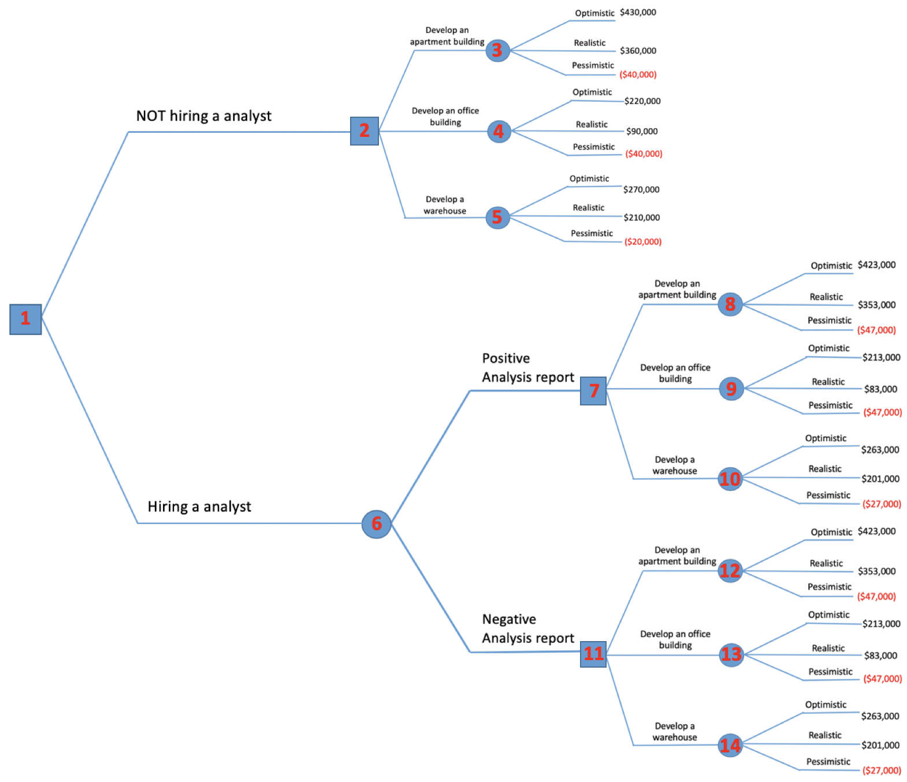
Figure 1

2. EMVs for each alternative.
Given the probability of all three economic conditions and using expected monetary values, we calculate the EMVs.
(1) EMV for not hiring a business analyst.
If the company doesn’t hire a business analyst, the EMV for developing an apartment building is $341900, the EMV for developing an office building is $123800, the EMV for developing a warehouse is $206900. The EMV for developing an apartment is highest, which means developing an apartment is most profitable.
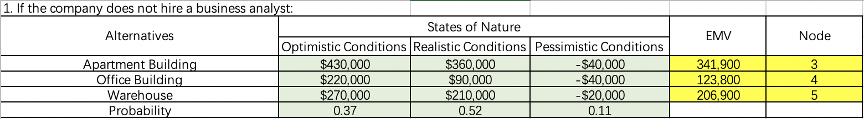
Table 2
(2) EMV for hiring a business analyst.
If the company hire a business analyst, the highest EMV for positive report results is $345300 which is about developing an apartment building, the highest EMV for negative report results is $151000 which is also about developing an apartment building. Therefore, the EMV for hiring a business analysis is $259808.
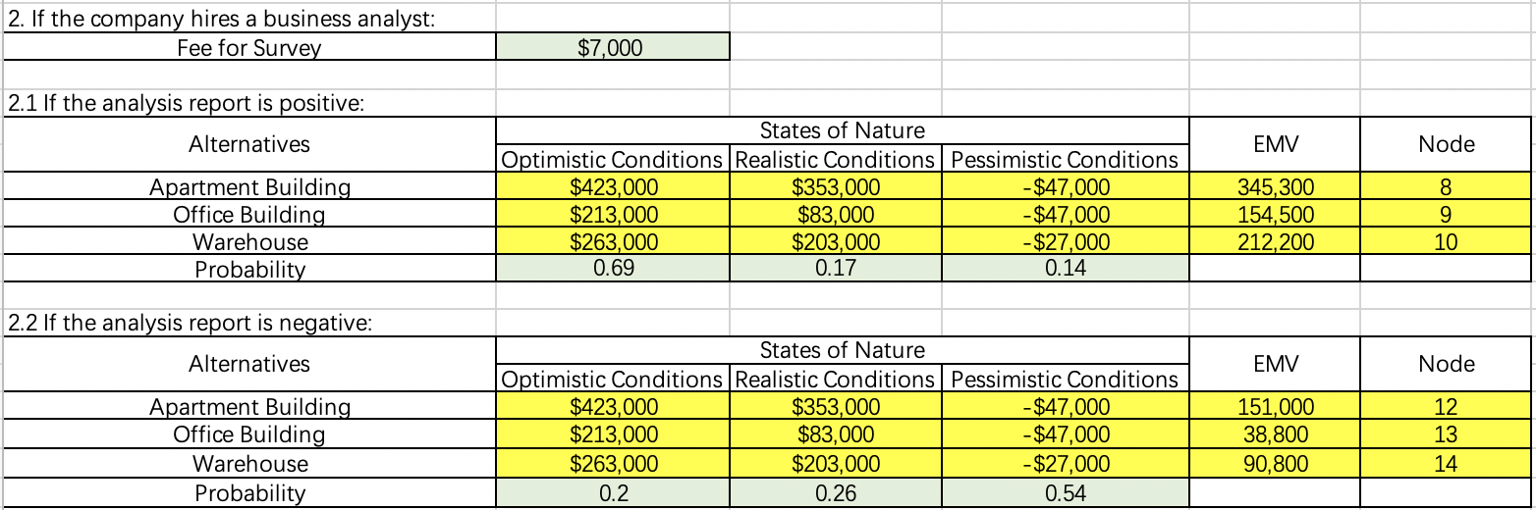
Table 3
(3) Final solution and recommendation.
Under the given condition and known probability, the EMV for hiring an analyst is $259808, EMV for not hiring an analyst is $341900. Obviously, not hiring an analyst and developing an apartment building are the most profitable choice.
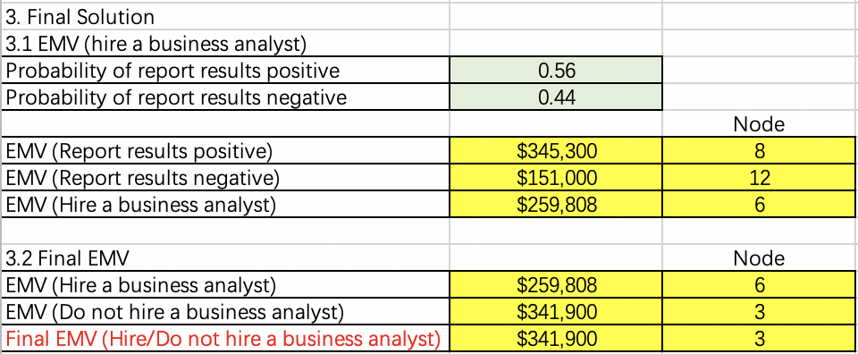
Table 4

3. Sensitivity analysis.
Assume that probability of positive report result is P, the probability of negative report result is 1-P, so:
$$EMV\left(hire an analyst\right)=P*EMV\left(positive\right)+\left(1-P\right)*EMV\left(negative\right)$$
Assume P equals 0.1, 0.2…1, the results of EMV for hiring an analyst are as follows:
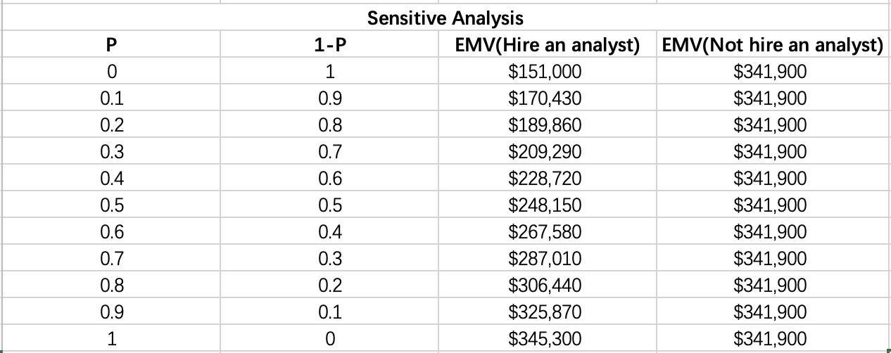
Table 5
Then we use line graph to show the trend of these two choices:

Figure 2
Basically, the blue line is under the orange line, indicating that the EMV (Not hire an analyst) is higher that EMV (Hire an analyst) in most of the time.
The cross point of the above graph is (0.98, 341900), meaning that first, when the probability of positive report results equals 0.98, the EMV (Hire an analyst) equals the EMV (Not hire an analyst). Also, there is 98% probability that EMV (Not hire an analyst) is greater than EMV (Hire an analyst).

4. The decision tree with payoffs, probabilities, and EMVs.
Excel is applied in constructing the decision tree. From this tree, the EMV for final decision is $341900 of developing an apartment and not hiring an analyst.
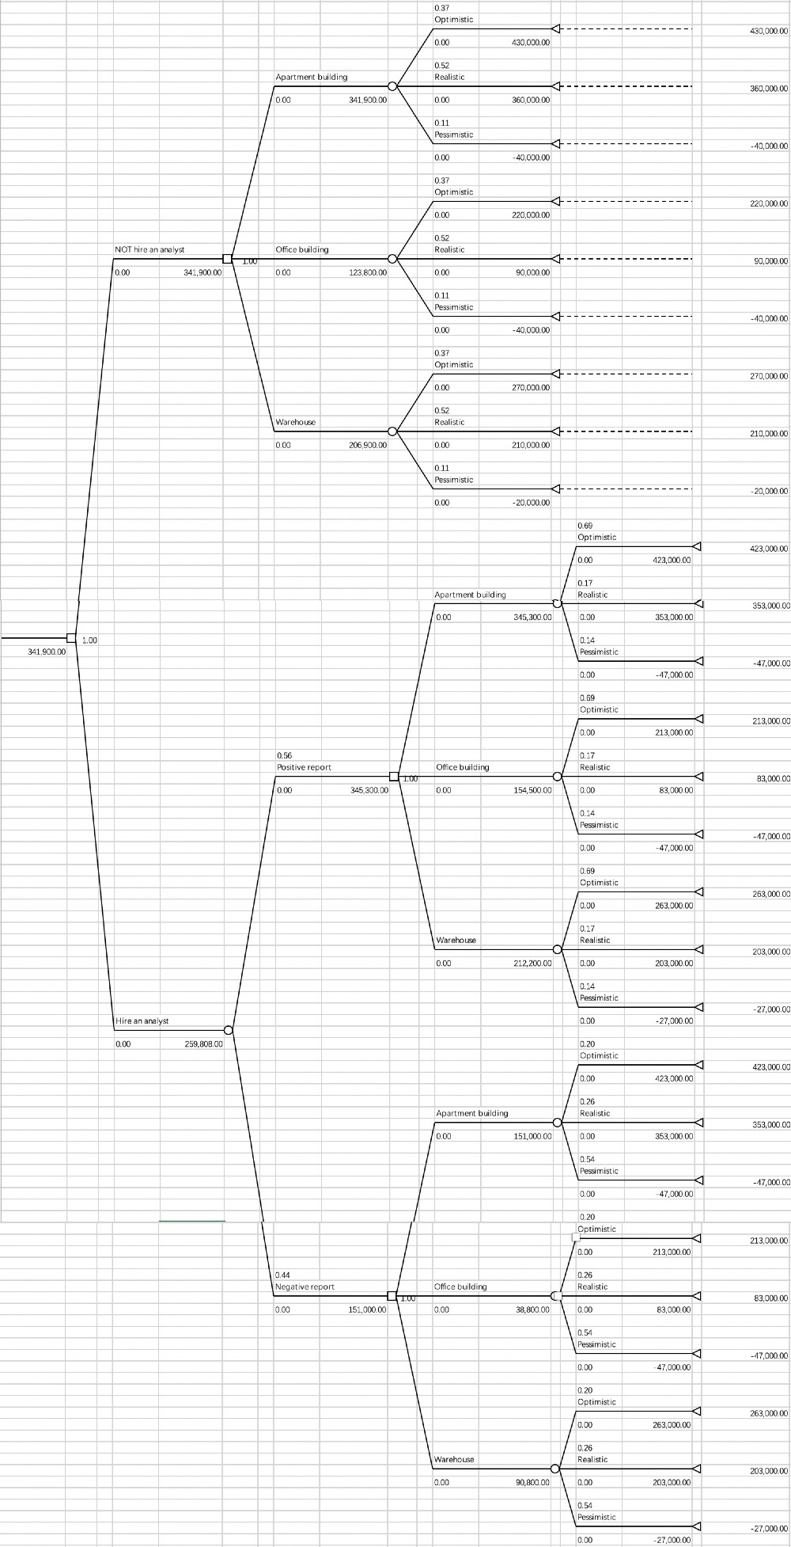
Figure 3

References
Worksheet in Excel file:
(i) A2 Text
(ii) Payoff Table - Template
(iii) Payoff Table - Solution and a sketch of a decision tree (without probability and EMVs)
(iv) EMV Calculation
(v) Sensitivity Analysis Diagram
(vi) Tree Plan Diagram of the Decision Tree

Tables
Table 1
Table 2
Table 3
Table 4
Table 5

Figures
Figure 1.
Figure 2.

Figure 3.

